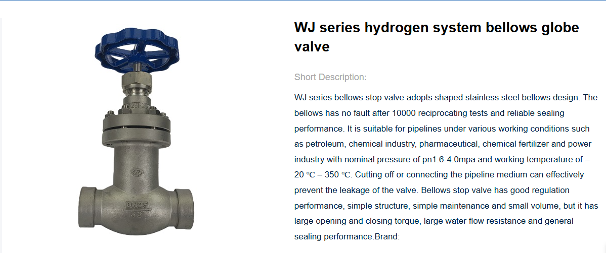

Working principle
Working Principle of WJ Series Bellows Globe Valve:
Depending on the stem pressure, the sealing surface of the disc is closely fitted with the sealing surface of the valve seat, preventing the flow of the medium.
Features of WJ series bellows globe valve
◆ The bellows globe valve, its key component is the metal bellows, the lower end and the valve stem assembly are automatically seamed and welded, and the upper end and the connecting plate are automatically seamed and welded, forming a metal barrier between the fluid medium and the atmosphere to ensure zero leakage of the valve stem;
◆ The valve disc adopts a conical design, the sealing surface and the medium are streamlined, the sealing performance is better, and the service life is longer;
◆ Double sealing design (bellows + packing) If the bellows fails, the valve stem packing will also avoid leakage and meet the international sealing standards;
◆ The valve cover has its own grease fitting, which can directly lubricate the valve stem, nut and bushing, unlike the traditional lubricating oil only on the thread;
◆ Ergonomically designed hand wheel, longer service life, easy and convenient operation, safer and more reliable; Application: hot oil system, steam system, cold and hot water system, etc.

