RELAY,PROTECTION,PN:HHD5-G,XINLING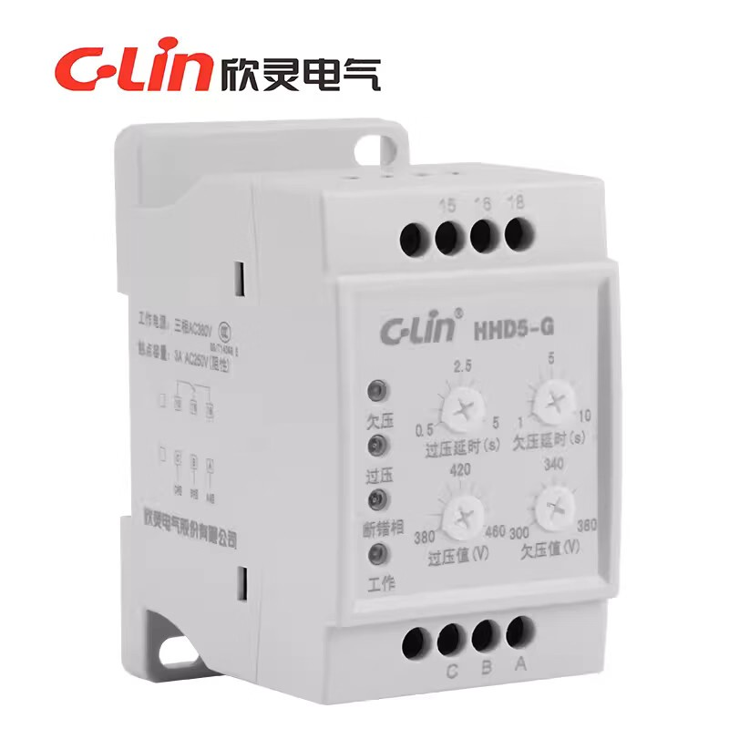

ENCODER,PN:HLE45-1024L-3FAC,WATANABESH
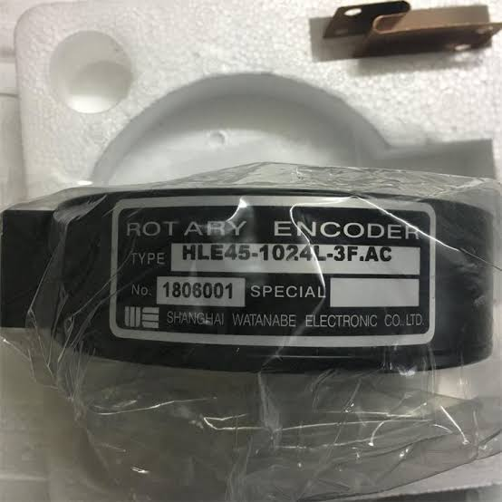

SENSOR,DIS,MM:VDM28-8-L1-IO/110/115B/122
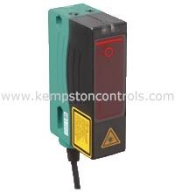

REMOTE CONTROL,PN:F24-10D,TELECRANE